**August 2019**



**Immersion Day**

*Creating an Elastic Load Balancer*

Table of Contents

[Overview 3](#_Toc386713396)

[Launch a Second Web Server 4](#_Toc386713397)

[Create an ALB 6](#_Toc386713398)

# Overview

This lab will walk the user through creating an ALB to load balance traffic across several EC2 nodes in a single Availability Zone.

**icons_07_bw.eps**This lab has a prerequisite of Immersion Day – Getting Started with EC2 and assumes that you have already launched your first web server. This lab will demonstrate configuring a farm of web servers from the Immersion Day – Getting Started with EC2 lab to use ALB for its load balancing needs.

# 

# Launch a Second Web Server

Let’s launch another web server, similar to our existing web server instance.

1. 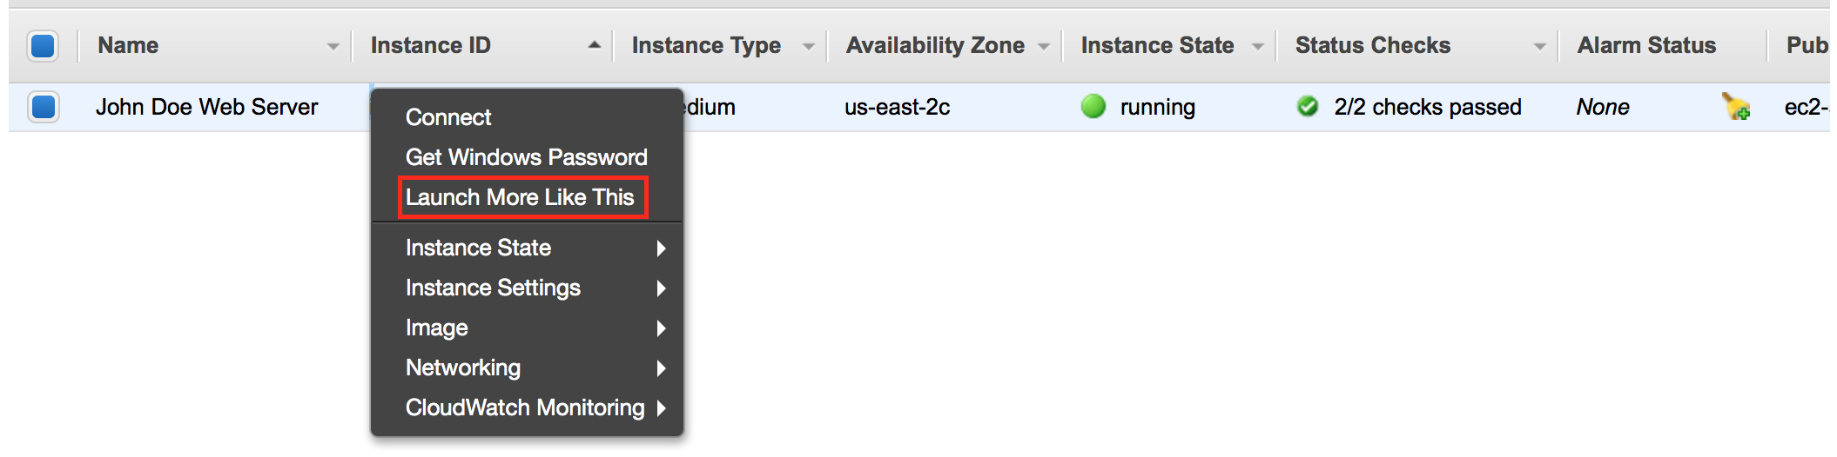Right click your web server and choose **Launch More Like This**. As it implies, this feature will launch another web server similar to the existing web server.

(Please note that launch more like this does not clone the instance. It only replicates configuration details so any webserver configuration on the intance will need to be supplied via AMI or user data. For more details, please check the reference in the end of the document )[[1]](#endnote-1)

1. On the next screen, scroll down to the **Tags** section and click **Edit Tags**.

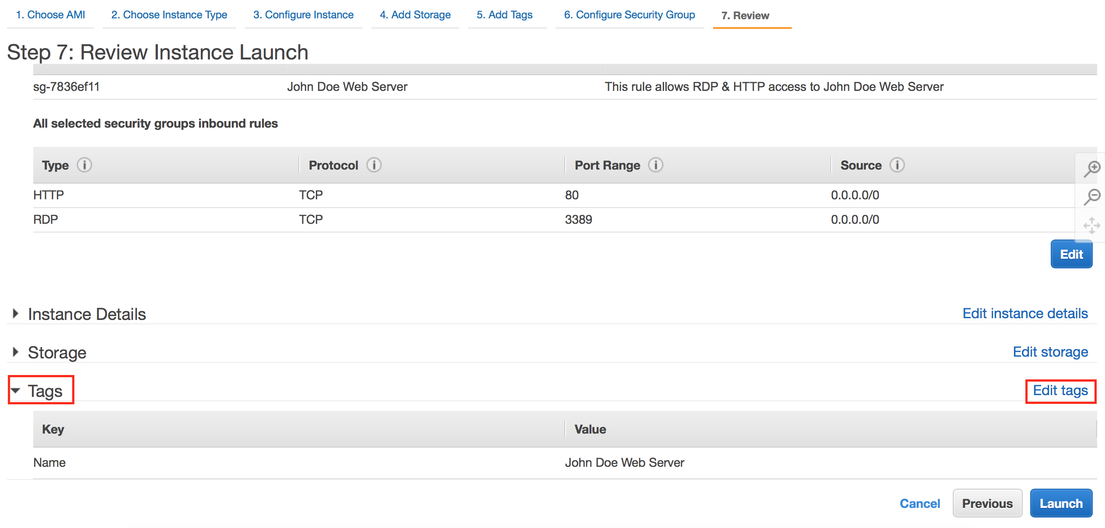

1. Change the **Value** of the **Name** tag to something different than the first instance, like [Your name] Webserver 2. Click **Next: Configure Security Group**

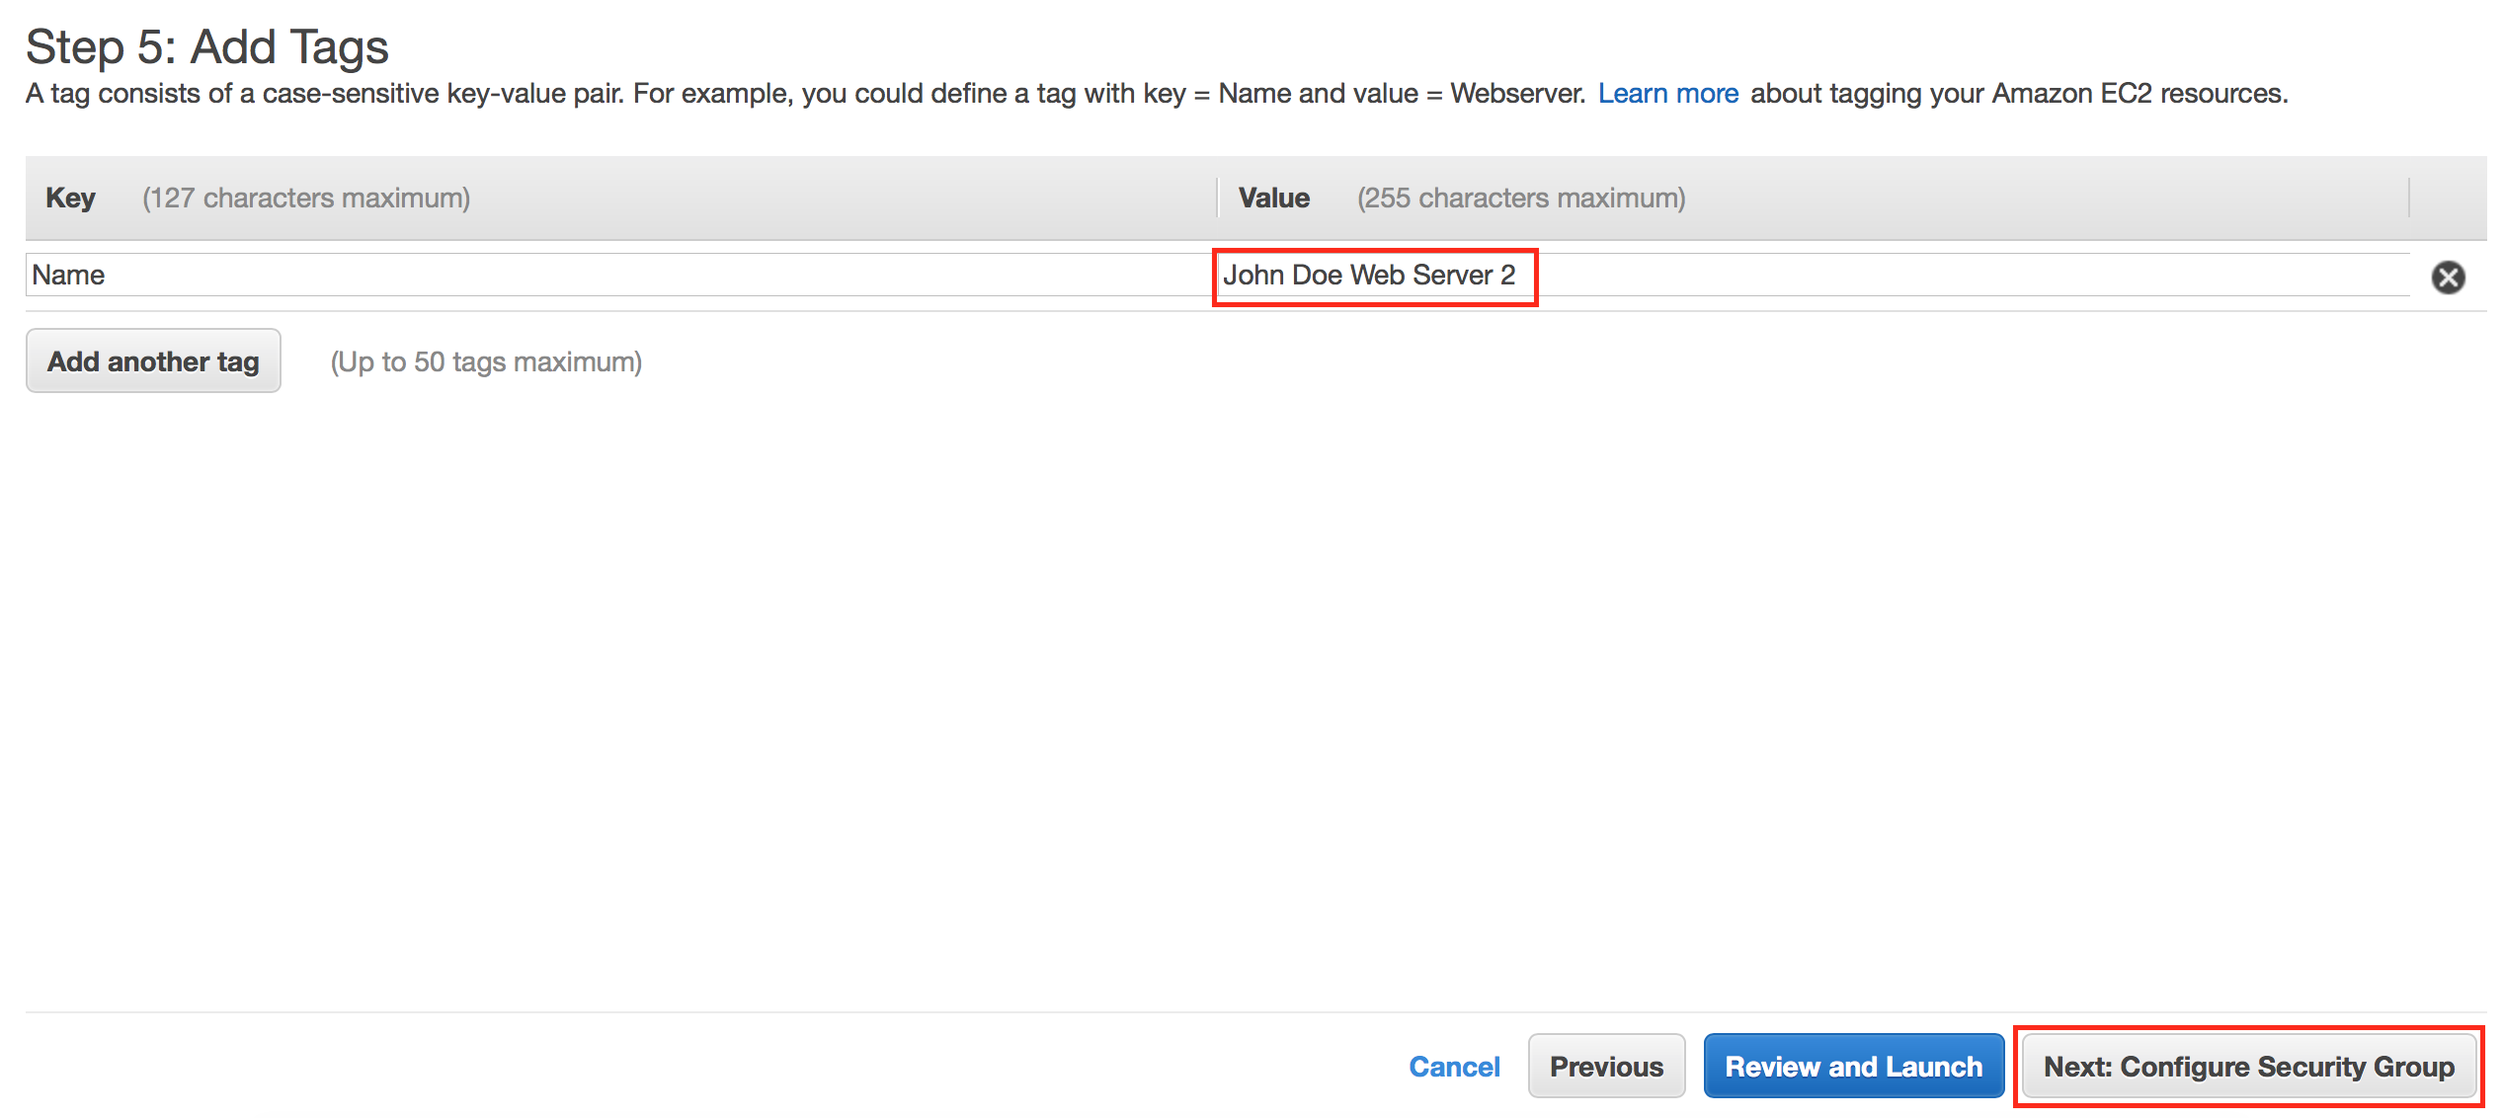

1. 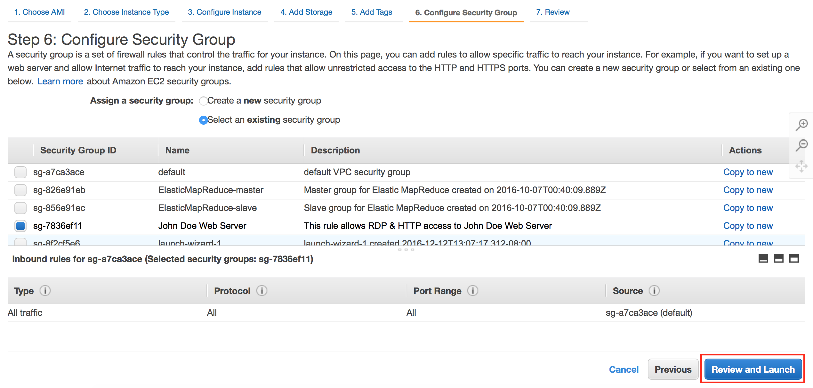Click the **Review and Launch** button to continue to the next screen where you’ll launch the additional server.
2. Click on **Launch** to launch your additional instance. Like your first instance, this newly launched instance will take a few minutes to boot and configure itself.

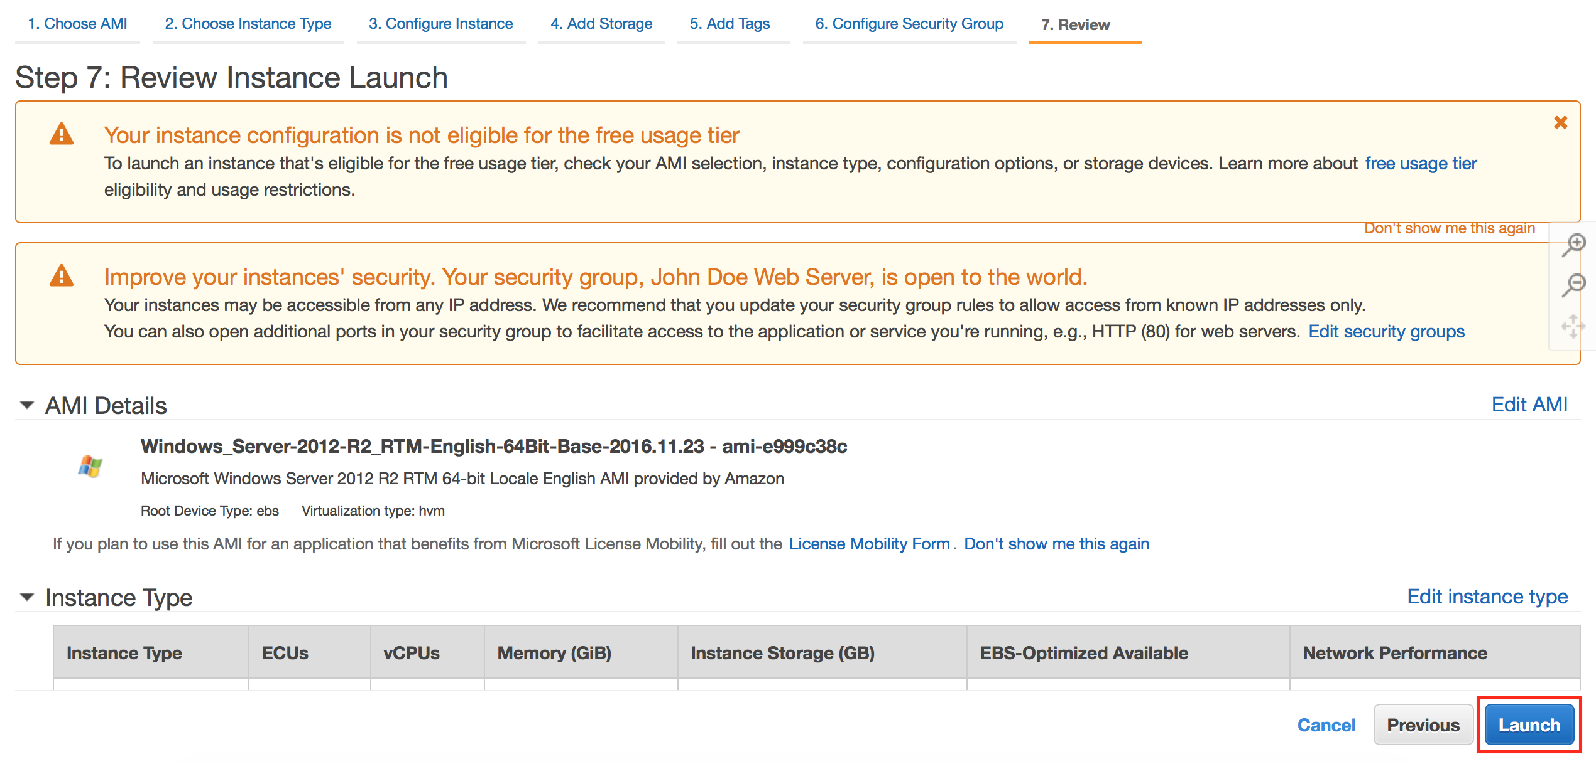

1. Please select the existing key pair that you created and click Launch Instances.



1. Once the second web server has passed its status checks, confirm the web server is operational by browsing to its web site using its public DNS. You’ll see both instances listed in your console as shown below.

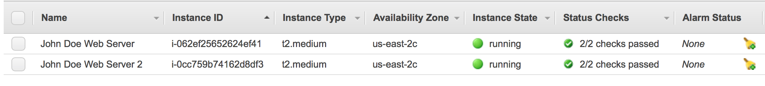

# Create an ALB

You now have two web servers, but you need a load balancer in front of these servers to give your users a single location for accessing both servers and to balance user requests across your web server farm.

1. 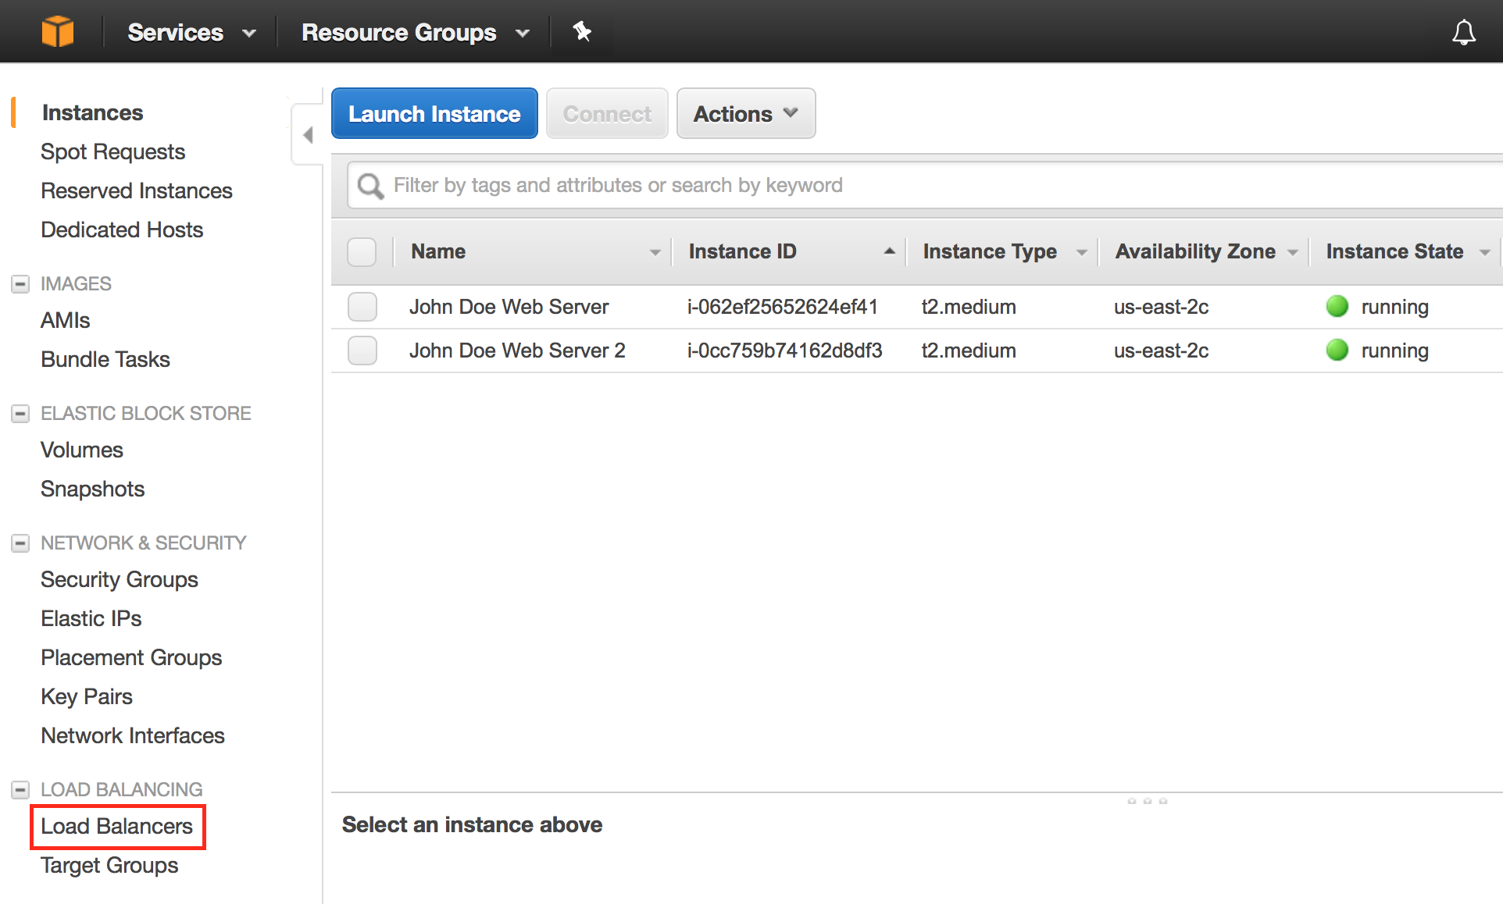Click on the **Load Balancers** link in the EC2 Console.

1. Click on **Create Load Balancer** button.

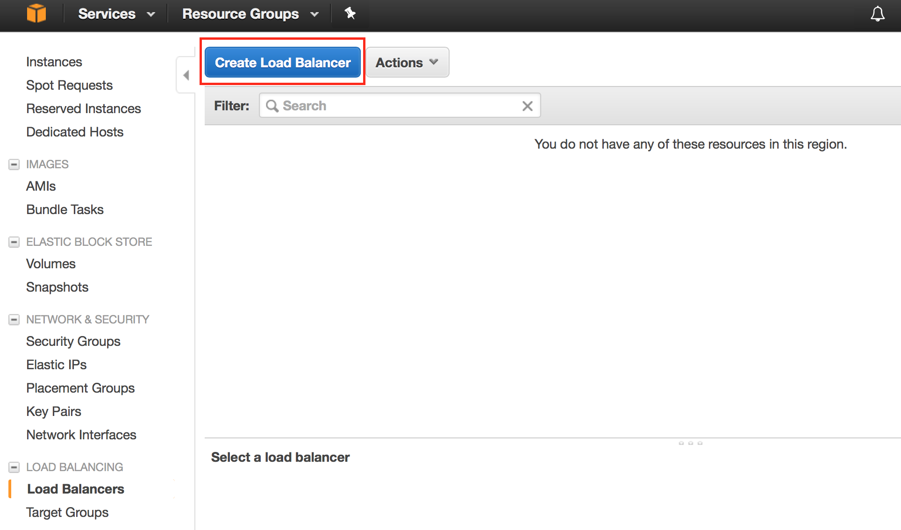

1. We will be creating a Application Load Balancer today, so please select that option and click **Continue** to proceed to the next step.

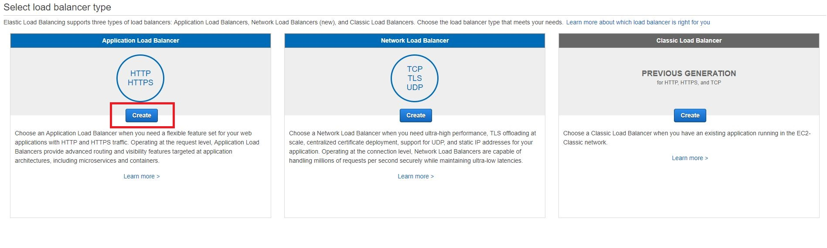

1. For the load balancer name, type a name like [YourName]-ALB, keep scheme as “internet-facing”, and IP address type as “ipv4”. Verify that HTTP is selected for the load balaner protocol with load balancer port 80. Select the VPC and subnet where the web server is running in, then click **Next: Assign Security Groups**.

*Note: Please note that spaces are not allowed in the ALB name.*

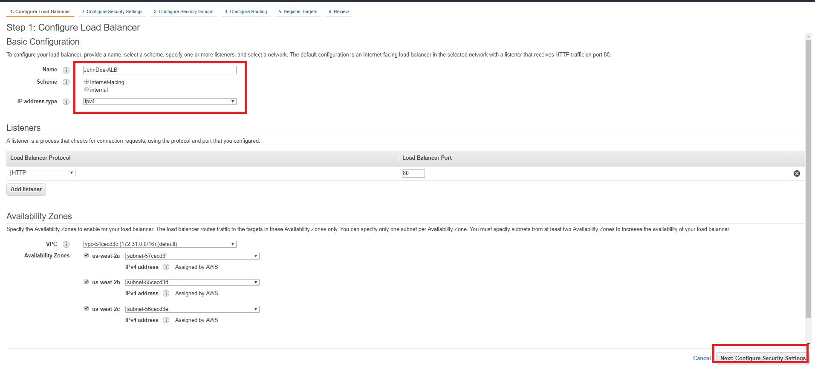

1. On the next screen, it shows the load balancer is not using secure listener. In production environment it is recommended to use HTTPS protocol for front-end connection. In this lab, we will skip that part. Click **Next: Configure Security Groups.**
2. On the next screen we’ll create a new security group for our ALB. Name your security group something like **[Your Name] ALB SG,** and allow HTTP traffic to be passed to your instances by creating a rule of type **HTTP** for port 80, then click **Next:Configure Routing**.

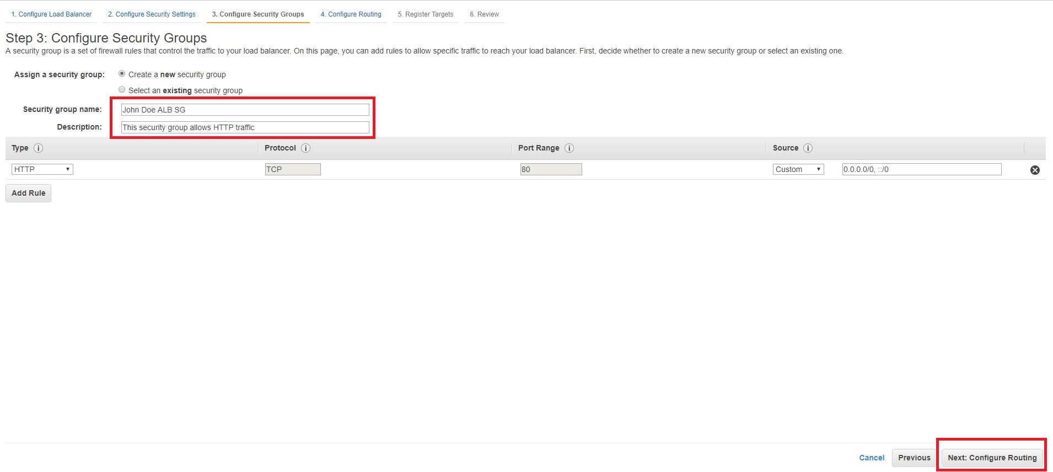

1. On the next screen you will configure the target group and health check. Name the target group like something **[Your Name]targetgroup,** then select target type as Instance. Keep Protocols and Port as default(HTTP & 80) Verify health checks protocol is HTTP and Path is /. Then click **Next:Register Targets.**

*Note: Please note that spaces are not allowed in the Target group name.*

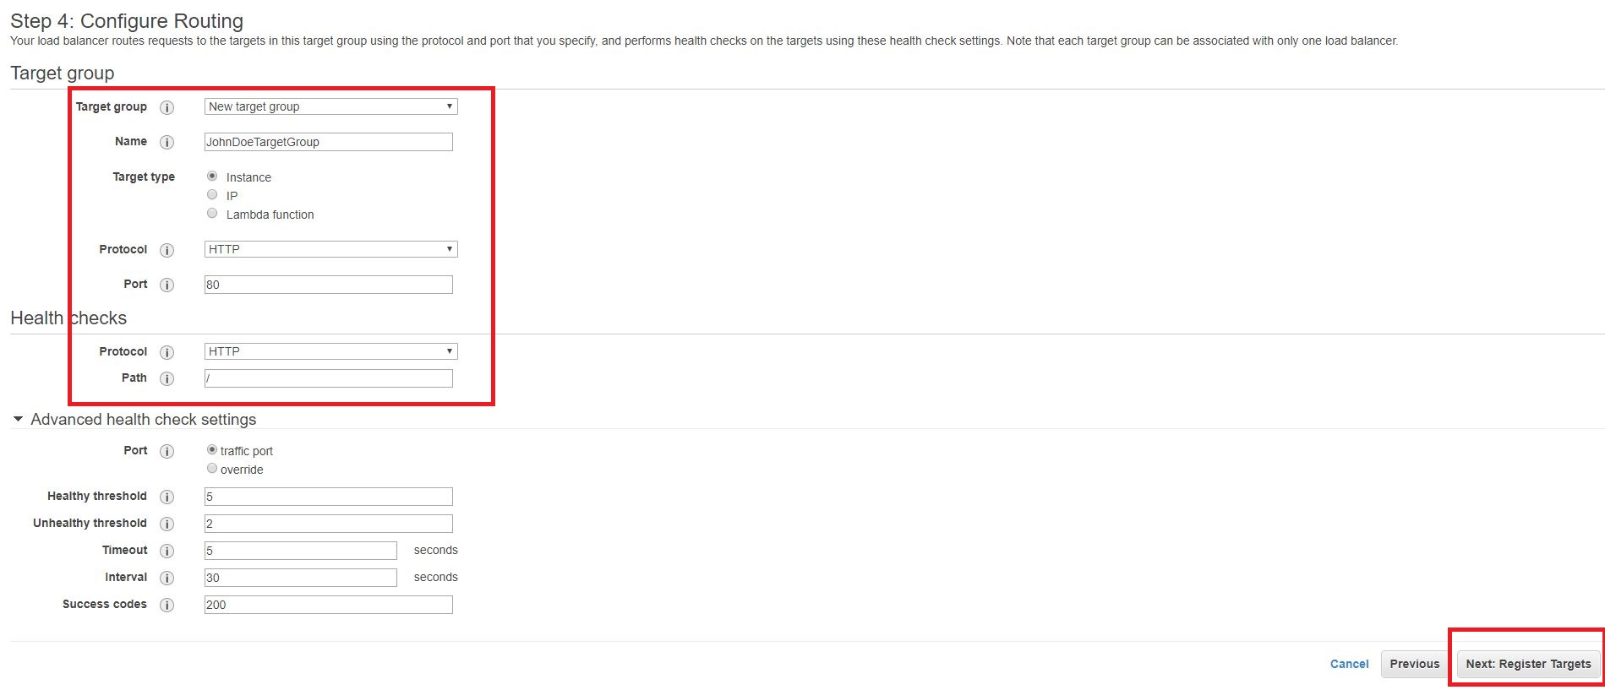

1. Select both your Web Servers you created and click **Add to registered** to add them to your ALB and click **Next:Review**.

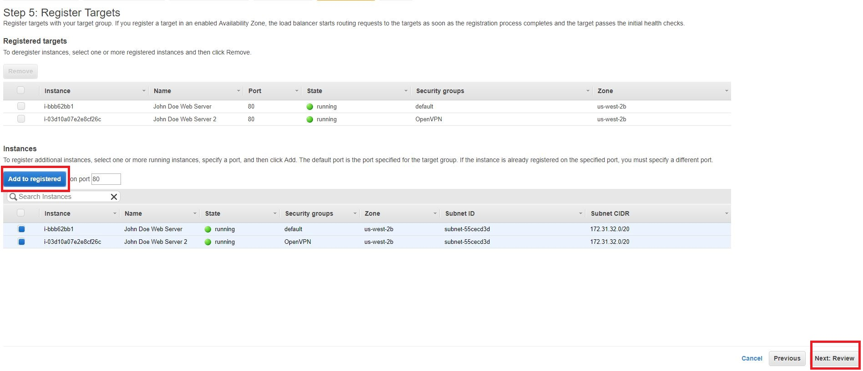

1. Review your ALB settings and click **Create** (followed by clicking **Close**).

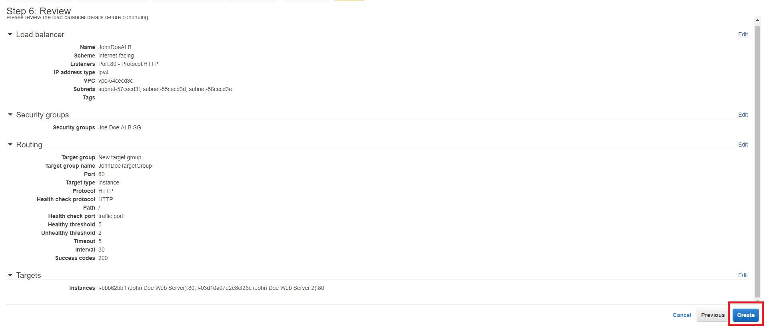

1. AWS is now creating your ALB. It will take a couple of minutes to establish your load balancers, attach your web servers, and pass a couple of health checks. **Click** on your load balancer, once the State is showing active, **Click** target Groups *and* then select Targets tab, you should see both of your web servers are healthy**.**

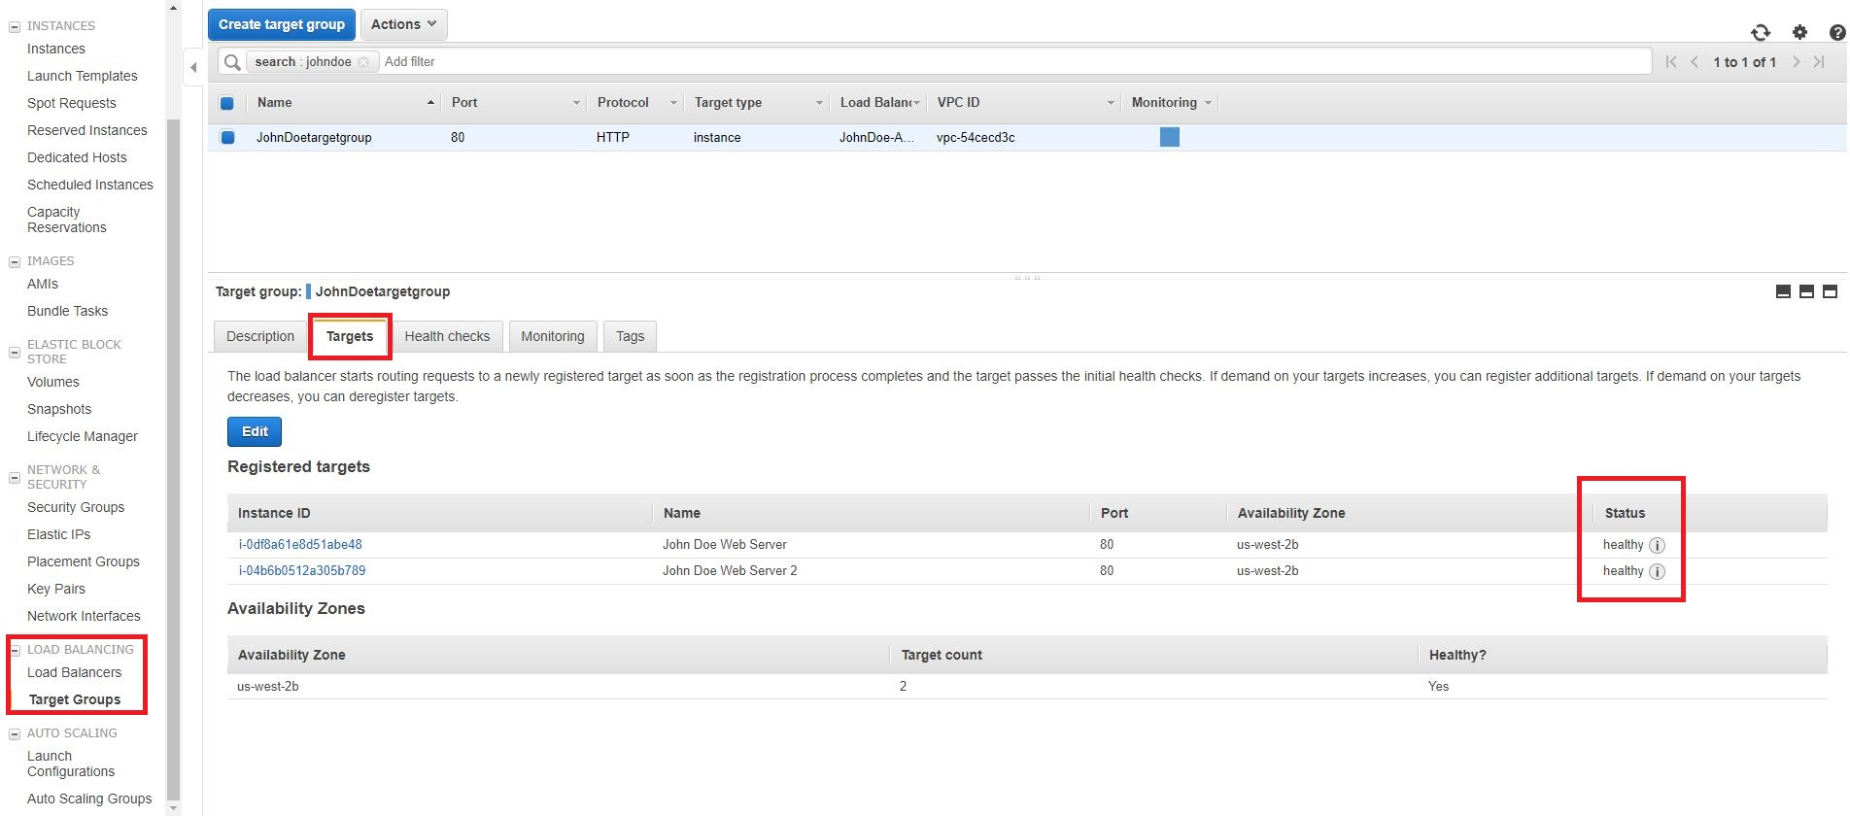

1. Switch back to Load Balancers, Under the Description tab, copy the ALB’s DNS name.

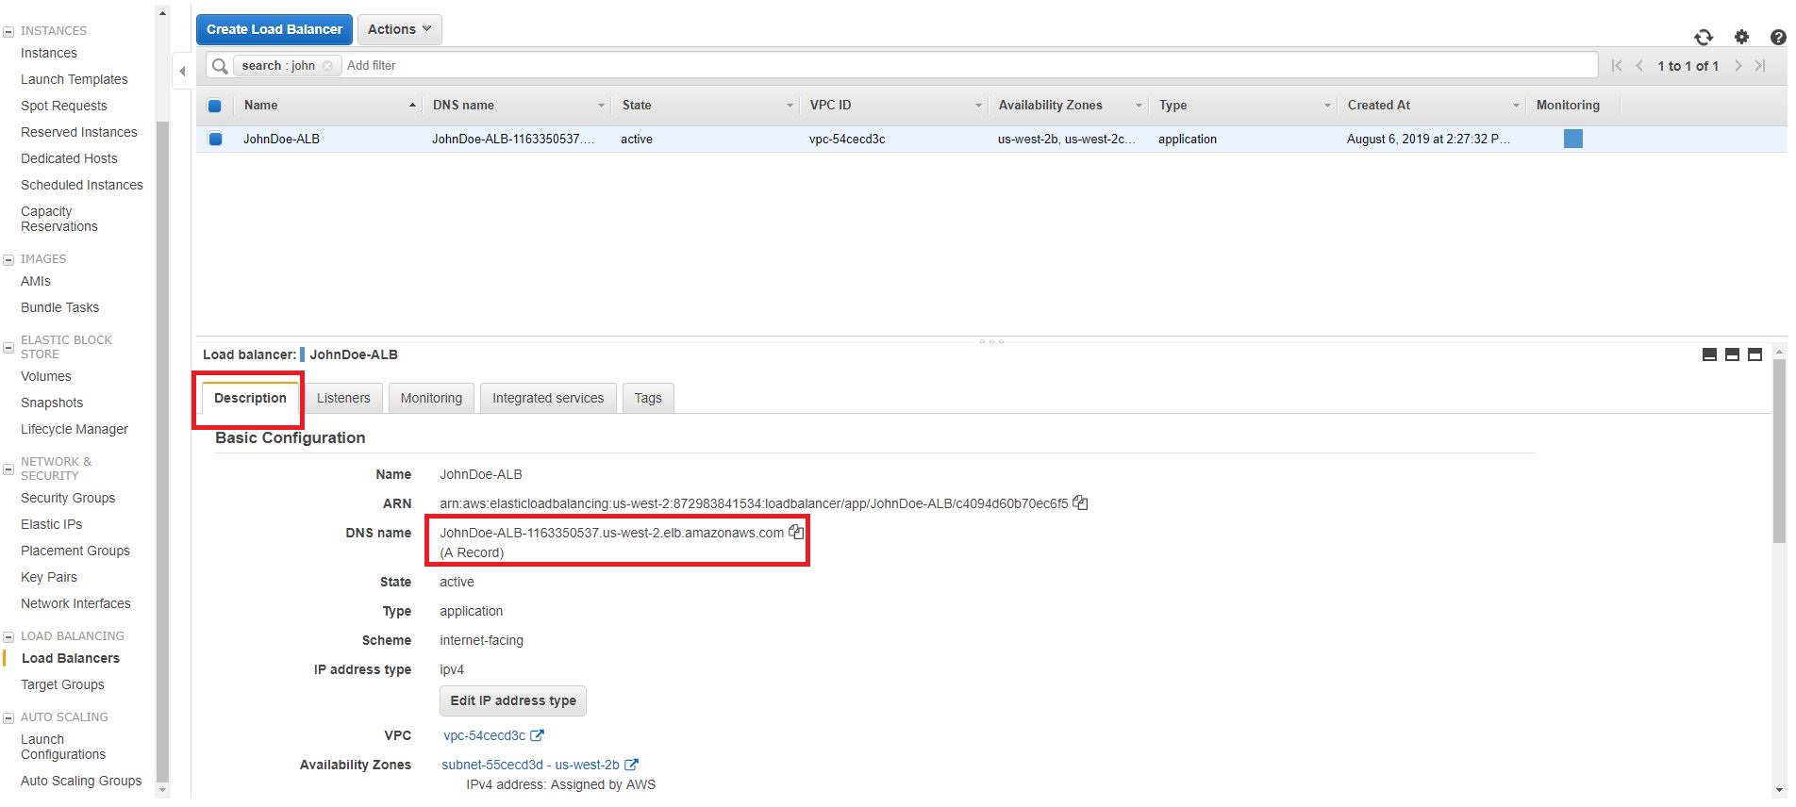

1. Open the ALB URL in a new browser tab. Hit the browser refresh button and you should cycle through your web servers (you may need to do a “Shift-F5” or “Shift-Refresh” as some browsers like Chrome are pretty aggressive in locally caching web pages).

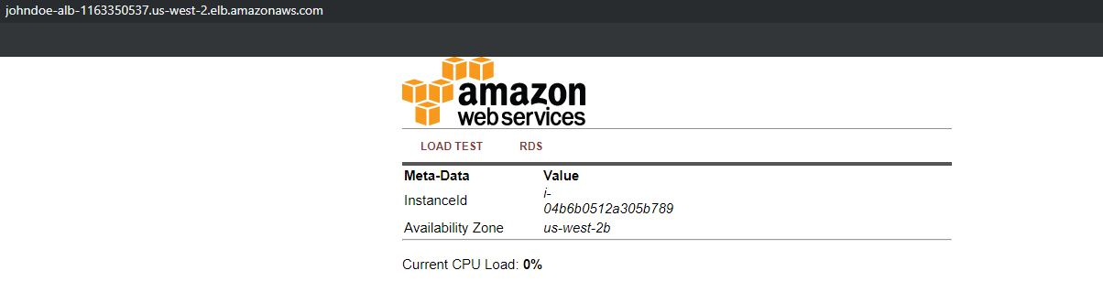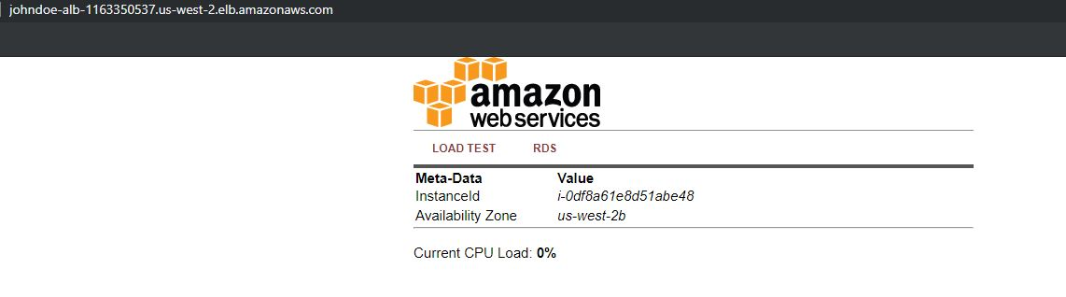

1. Congratulations, you’ve created a load balanced website.

1. https://docs.aws.amazon.com/AWSEC2/latest/UserGuide/launch-more-like-this.html [↑](#endnote-ref-1)